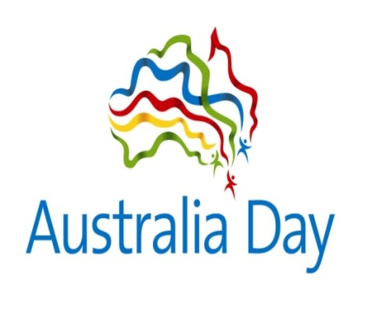
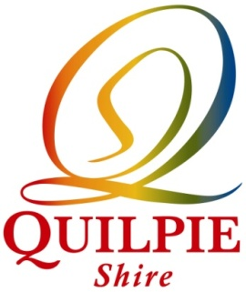

Australia Day Awards 2020

CITIZEN OF THE YEAR Michelle Donohue

CERTIFICATES OF RECOGNITION Danielle Dunlop
Roger Volz
Bill Watts

COMMUNITY GROUP AWARD Quilpie QCWA

OUTSTANDING JUNIOR ACHIEVEMENT AWARD Mia Haylock

OUTSTANDING ACHIEVEMENT AWARD Janet Hennessy

SPORTS & RECREATION AWARD Bella Challenor

CERTIFICATES OF APPRECIATION Jan McConnell
Sallyann Challenor

